Data dict: 02. AdventureWorks _ Data Dictionary.pdf - Google Drive

Query 1: Sales Volume L12M

Question: Calc Quantity of items, Sales value & Order quantity by each Subcategory in L12M.

WITH
sales_order_with_date AS(
SELECT
sales_detail.SalesOrderID,
sales_detail.ProductID,
sales_detail.OrderQty,
sales_detail.LineTotal,
DATE(sales_header.OrderDate) as order_date,
MAX(DATE(sales_header.OrderDate)) OVER() AS last_order_date,
DATE_SUB(MAX(DATE(sales_header.OrderDate)) OVER(), INTERVAL 12 MONTH) L12M
FROM `adventureworks2019.Sales.SalesOrderDetail` sales_detail
INNER JOIN `adventureworks2019.Sales.SalesOrderHeader` sales_header
ON sales_detail.SalesOrderID = sales_header.SalesOrderID
),
sales_in_L12M AS(
SELECT
s.SalesOrderID, s.OrderQty, s.LineTotal,
FORMAT_DATE('%b %Y', s.order_date) period,
p.ProductSubcategoryID,
sub.name AS product_subcategory
FROM sales_order_with_date s
LEFT JOIN `adventureworks2019.Production.Product` p ON s.ProductID = p.ProductID
LEFT JOIN `adventureworks2019.Production.ProductSubcategory` sub ON CAST(p.ProductSubcategoryID AS INT64) = sub.ProductSubcategoryID
WHERE order_date >= L12M
)
SELECT
period,
product_subcategory,
SUM(OrderQty) AS qty_item,
ROUND(SUM(LineTotal), 4) as total_sales,
COUNT(SalesOrderID) AS oder_cnt
FROM sales_in_L12M
GROUP BY period, product_subcategory
ORDER BY period DESC, product_subcategory;

Output:
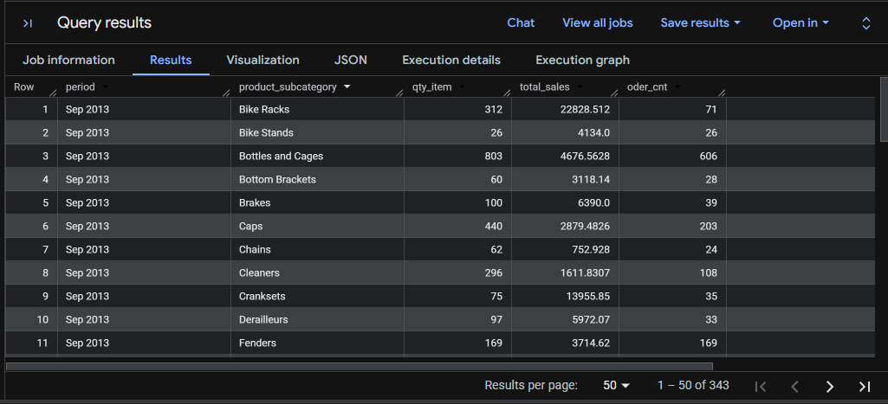

Query 2: YoY Growth Rate by Category

Question: Calc % YoY growth rate by SubCategory & release top 3 cat with highest grow rate. Can use metric: quantity_item. Round results to 2 decimal.

WITH
sales_with_date AS (
SELECT
sales_detail.SalesOrderID order_id,
sales_detail.ProductID product_id,
sales_detail.OrderQty order_qty,
DATE(sales_header.OrderDate) as order_date,
FROM `adventureworks2019.Sales.SalesOrderDetail` sales_detail
INNER JOIN `adventureworks2019.Sales.SalesOrderHeader` sales_header
ON sales_detail.SalesOrderID = sales_header.SalesOrderID
),
sales_with_date_subcate_name AS (
SELECT
order_id, product_id, order_qty,
EXTRACT(YEAR FROM order_date) order_year,
p.ProductSubcategoryID product_subcate_id,
sub.Name subcate_name
FROM sales_with_date s
LEFT JOIN `adventureworks2019.Production.Product` p ON s.product_id = p.ProductID
LEFT JOIN `adventureworks2019.Production.ProductSubcategory` sub ON CAST(p.ProductSubcategoryID AS INT64) = sub.ProductSubcategoryID
),
qty_sum_by_subcate AS(
SELECT order_year, subcate_name, SUM(order_qty) qty_item
FROM sales_with_date_subcate_name
GROUP BY subcate_name, order_year
),
qty_growth AS(
SELECT
a.order_year, a.subcate_name, a.qty_item,
b.order_year prev_year, b.qty_item prev_qty_item,
ROUND((a.qty_item/b.qty_item - 1), 2) qty_diff,
DENSE_RANK() OVER(ORDER BY ROUND((a.qty_item/b.qty_item - 1), 2) DESC) as growth_rank
FROM qty_sum_by_subcate a
LEFT JOIN qty_sum_by_subcate b ON a.subcate_name = b.subcate_name AND a.order_year = b.order_year + 1
)
SELECT subcate_name Name, qty_item, prev_qty_item prv_qty, qty_diff
FROM qty_growth WHERE growth_rank <= 3 ORDER BY qty_diff DESC;

Output:

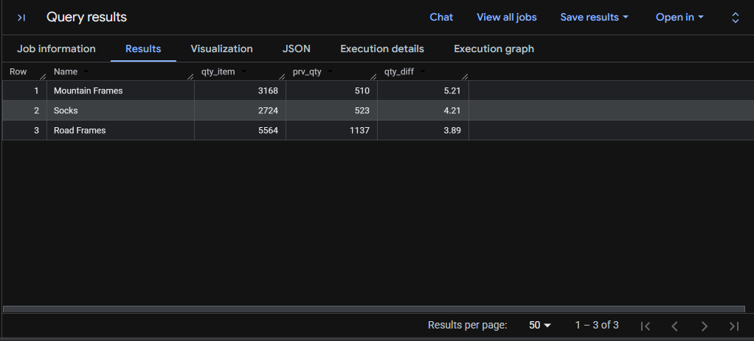

Query 3: Top Territories by Year

Question: Ranking Top 3 TeritoryID with biggest Order quantity of every year. If there's TerritoryID with same quantity in a year, do not skip the rank number.

WITH
territory_vs_order_count AS (
SELECT
EXTRACT(YEAR FROM OrderDate) yr,
TerritoryID,
SUM(OrderQty) order_cnt
FROM `adventureworks2019.Sales.SalesOrderDetail` sales_detail
INNER JOIN `adventureworks2019.Sales.SalesOrderHeader` sales_header
ON sales_detail.SalesOrderID = sales_header.SalesOrderID
GROUP BY EXTRACT(YEAR FROM OrderDate), TerritoryID
),
ranking_order_quantity AS(
SELECT
yr, TerritoryID, order_cnt,
DENSE_RANK() OVER(PARTITION BY yr ORDER BY order_cnt DESC) rk
FROM territory_vs_order_count
)
SELECT * FROM ranking_order_quantity WHERE rk <= 3 ORDER BY yr DESC;

Output:

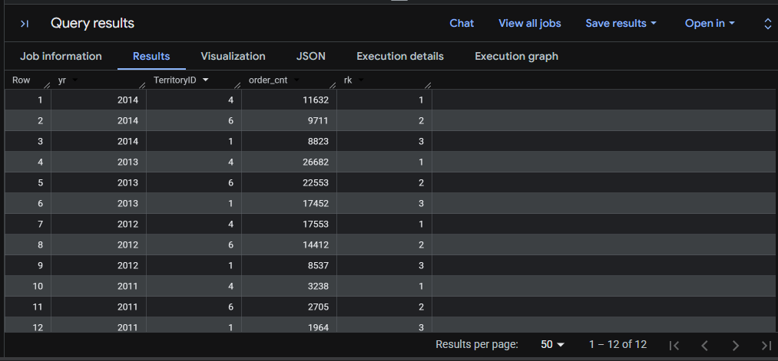

Query 4: Seasonal Discount Efficiency

Question: Calc Total Discount Cost belongs to Seasonal Discount for each SubCategory.

WITH
combined_sales_info AS(
SELECT
detail.ProductID, product.ProductSubcategoryID, subcate.Name subcate_name,
header.OrderDate order_date, detail.OrderQty order_qnt, detail.UnitPrice unit_price,
detail.SpecialOfferID, offer.DiscountPct discount_pct, offer.Type discount_type
FROM `adventureworks2019.Sales.SalesOrderDetail` detail
INNER JOIN `adventureworks2019.Sales.SalesOrderHeader` header ON detail.SalesOrderID = header.SalesOrderID
INNER JOIN `adventureworks2019.Sales.SpecialOffer` offer ON detail.SpecialOfferID = offer.SpecialOfferID
INNER JOIN `adventureworks2019.Production.Product` product ON detail.ProductID = product.ProductID
INNER JOIN `adventureworks2019.Production.ProductSubcategory` subcate ON CAST(product.ProductSubcategoryID AS INT64) = subcate.ProductSubcategoryID
),
calculated_discount_cost AS(
SELECT
EXTRACT(YEAR FROM order_date) year, subcate_name,
(discount_pct * unit_price * order_qnt) discount_cost
FROM combined_sales_info WHERE discount_type = 'Seasonal Discount'
)
SELECT year, subcate_name, SUM(discount_cost) total_cost
FROM calculated_discount_cost GROUP BY year, subcate_name ORDER BY year;

Output:

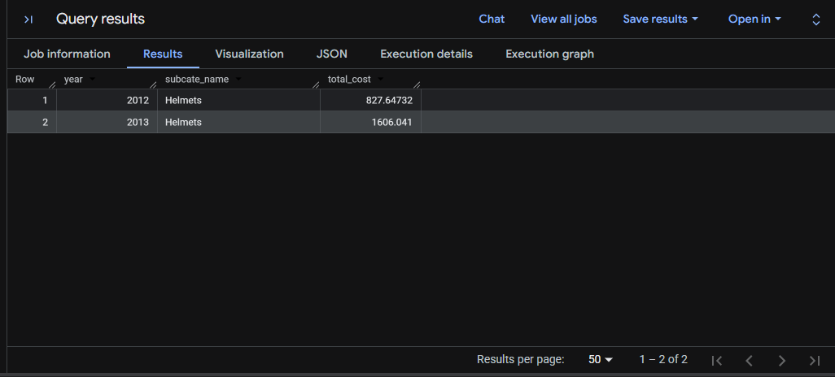

Query 5: Cohort Retention Rate

Question: Retention rate of Customer in 2014 with status of Successfully Shipped (Cohort Analysis).

WITH successful_order AS (
SELECT
EXTRACT(MONTH FROM ModifiedDate) order_month, CustomerID customer_id
FROM `adventureworks2019.Sales.SalesOrderHeader`
WHERE EXTRACT(YEAR FROM ModifiedDate) = 2014 AND Status = 5 ORDER BY customer_id, order_month
),
rank_time_order AS (
SELECT *, ROW_NUMBER() OVER(PARTITION BY customer_id ORDER BY order_month) order_time
FROM successful_order
),
first_order AS (
SELECT order_month AS month_join, customer_id
FROM rank_time_order WHERE order_time = 1
),
find_month_diff AS (
SELECT distinct order_month, month_join, a.customer_id, (order_month - month_join) month_diff_num
FROM successful_order a INNER JOIN first_order b ON a.customer_id = b.customer_id
ORDER BY month_join, order_month
)
SELECT month_join, CONCAT('M-',month_diff_num) month_diff, COUNT(customer_id) customer_count
FROM find_month_diff GROUP BY month_join, CONCAT('M-',month_diff_num) ORDER BY month_join, month_diff;

Output:

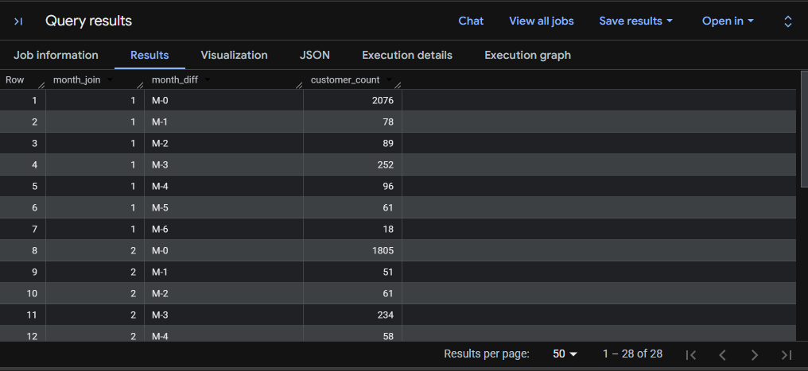

Query 6: Stock Trend MoM

Question: Trend of Stock level & MoM diff % by all product in 2011. If %gr rate is null then 0. Round to 1 decimal.

WITH
stock_info_2011 AS (
SELECT
EXTRACT(YEAR FROM o.ModifiedDate) yr, EXTRACT(MONTH FROM o.ModifiedDate) mth,
StockedQty, o.ProductID, p.Name product_name
FROM `adventureworks2019.Production.WorkOrder` o
INNER JOIN `adventureworks2019.Production.Product` p ON o.ProductID = p.ProductID
WHERE EXTRACT(YEAR FROM o.ModifiedDate) = 2011
),
sum_stock_qty AS(
SELECT product_name, mth, yr, SUM(StockedQty) stock_qty
FROM stock_info_2011 GROUP BY product_name, mth, yr
)
SELECT
a.product_name, a.mth, a.yr, a.stock_qty, b.stock_qty AS stock_prv,
IFNULL(ROUND((a.stock_qty / b.stock_qty - 1) *100.0,1), 0) diff
FROM sum_stock_qty a
LEFT JOIN sum_stock_qty b ON a.product_name = b.product_name AND a.mth = b.mth + 1
ORDER BY product_name, a.mth DESC;

Output:

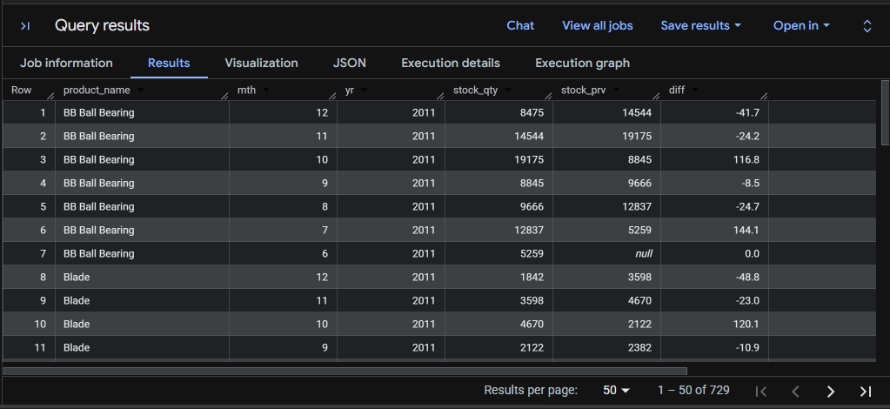

Query 7: Stock-to-Sales Ratio

Question: Calc Ratio of Stock / Sales in 2011 by product name, by month. Order results by month desc, ratio desc. Round Ratio to 1 decimal.

WITH
sales_2011 AS(
SELECT
EXTRACT (MONTH FROM OrderDate) mth, EXTRACT (year FROM OrderDate) yr,
detail.ProductID, p.Name, SUM(OrderQty) sales
FROM `adventureworks2019.Sales.SalesOrderDetail` detail
INNER JOIN `adventureworks2019.Sales.SalesOrderHeader` header ON detail.SalesOrderID = header.SalesOrderID
INNER JOIN `adventureworks2019.Production.Product` p ON detail.ProductID = p.ProductID
WHERE EXTRACT (year FROM OrderDate) = 2011 GROUP BY 1, 2, 3, 4
),
stock_2011 AS (
SELECT
EXTRACT(MONTH FROM o.ModifiedDate) mth, EXTRACT(YEAR FROM o.ModifiedDate) yr,
o.ProductID, p.Name product_name, SUM(StockedQty) stock
FROM `adventureworks2019.Production.WorkOrder` o
INNER JOIN `adventureworks2019.Production.Product` p ON o.ProductID = p.ProductID
WHERE EXTRACT(YEAR FROM o.ModifiedDate) = 2011 GROUP BY 1,2,3,4)
SELECT
sa.mth, sa.yr, sa.ProductId, sa.Name, sales, stock, ROUND((stock/sales), 1) ratio
FROM sales_2011 sa
LEFT JOIN stock_2011 st ON sa.mth = st.mth AND sa.productID = st.productID
ORDER BY 1 DESC, 7 DESC;

Output:

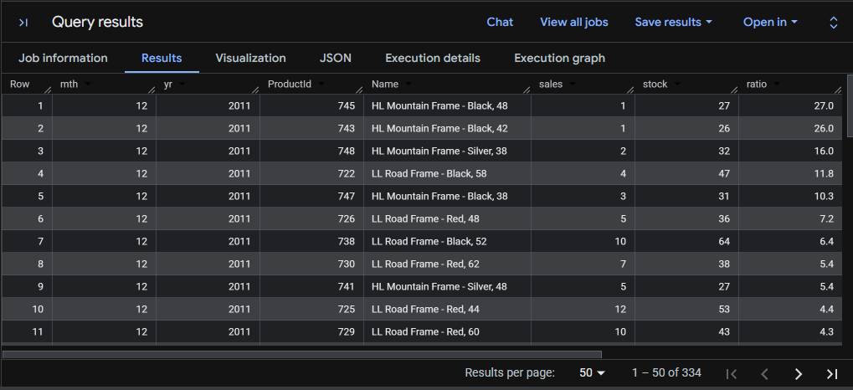

Query 8: Pending Orders Breakdown

Question: No of order and value at Pending status in 2014.

SELECT
EXTRACT(YEAR FROM header.ModifiedDate) yr, Status,
COUNT(DISTINCT header.PurchaseOrderID) order_cnt,
SUM(TotalDue) value
FROM `adventureworks2019.Purchasing.PurchaseOrderDetail` detail
LEFT JOIN `adventureworks2019.Purchasing.PurchaseOrderHeader` header
ON detail.PurchaseOrderID = header.PurchaseOrderID
WHERE EXTRACT(YEAR FROM header.ModifiedDate) = 2014 AND Status = 1
GROUP BY 1,2;

Output:

